# Access Review – HPA ERP Procedure for Asset Owners

**Purpose:**  Certify all HPA owners are authorized to access in-scope applications.

**Scope:**  Accounts with HPA access defined by Corporate HPA Standard and Aviation Business specific HPA accounts

**Procedure:**

AUL - Extract a list of all in-scope accounts

Notification - You will receive an email from the Access Review Workflow.

Extract the requested, in-scope user list and paste your data into the [User list extraction template](http://libraries.ge.com/download?fileid=849044929101&entity_id=66080671101&sid=101)

Steps:

1. Create a report of the application’s “menus submenus, and functions attached to a responsibility” by following the instructions & running the script provided in the attachment and paste in the User list template “Menu’s and Submenu’s” Worksheet.



1. Create a report of list of users and roles/responsibilities from the application and paste in the User list template “HPA users with roles” Worksheet.

Capture screen shots to document your extraction procedure

Include in screen shots:

* Application Name
* Number of records
* Time and date

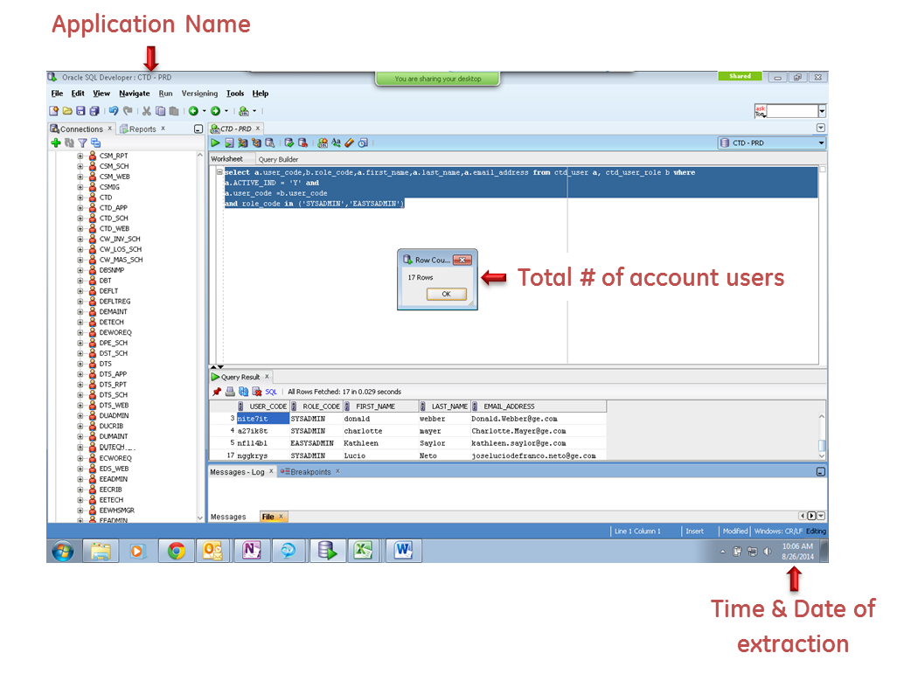

Defect Remediation – Submit your defect-free HPA active user list

Notification - You will receive a notification email from the Access Review Workflow

**When the Access Review workflow is returned to you, a Defect Review Report will be attached** identifying the accounts that have not been approved by the Authorized Approver.

Follow the instructions indicated in the Defect Report to disable unauthorized accounts:

* Inactive
* Revoked
* No Response from Manager
* OIA Review not Performed

**After remediating all defects**, generate a revised HPA active user list. Attach the revised list and resubmit the Access Review Workflow.